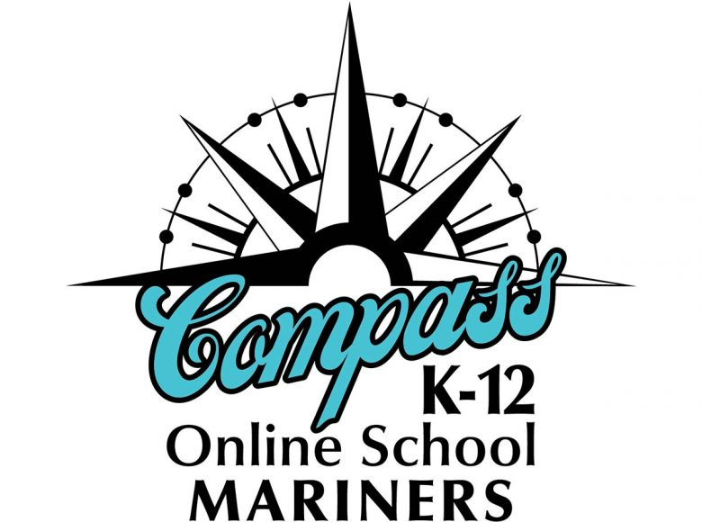
2021-22 School Supply List

- District issued Chromebook
- District issued stylus pen
- Two single subject notebooks
- Pencils
- Pack of markers or crayons

